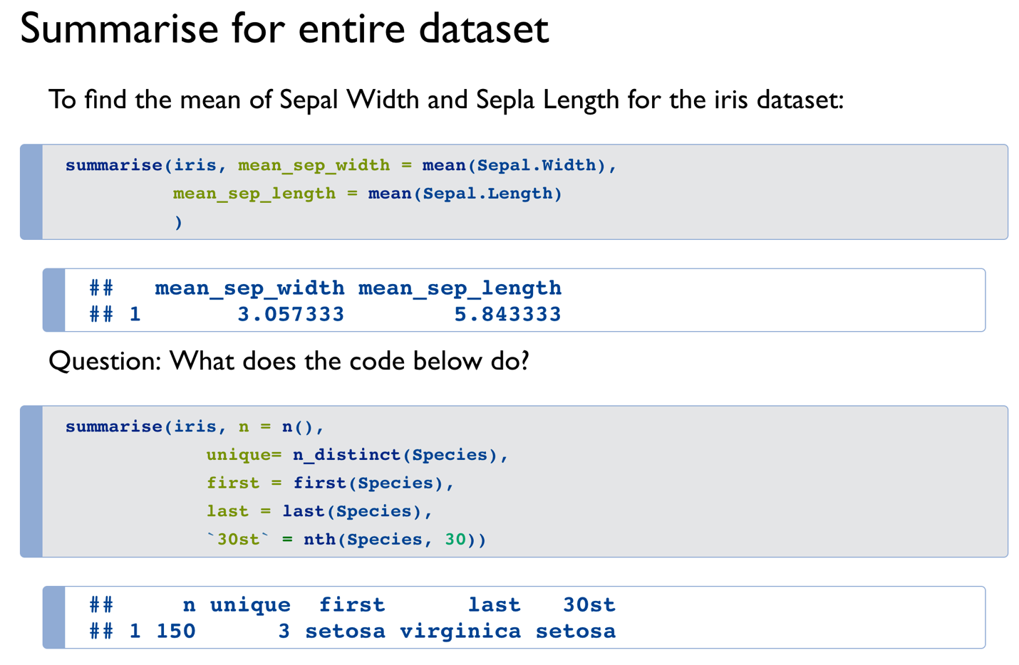

df <- gapminder %>%

filter(year == 2007) %>%

group_by(continent) %>%

summarise(mean_life_expt = mean(lifeExp),

counts = n())

## (1) making the bar chart

df %>% ggplot() +

geom_col(mapping = aes(x = continent, y = mean_life_expt, fill = continent)) +

coord_flip() + ## making bars horizontal

theme_bw() ## black and white theme

## (2) making pie chart

df %>% ggplot(mapping = aes(x = 1, y = counts, fill = continent)) +

geom_col(width = 1, color = "white") +

coord_polar(theta = "y") +

## adding labels

geom_label(mapping = aes(label = counts), ## alternatively use geom_text which has no border around the labels

color = "black", ## border colr

position = position_stack(vjust = 0.5),

show.legend = FALSE) +

theme_void() + ## clears backgrond

theme(legend.position = "bottom") ## move legend to bottom